Microsoft Excel Homework for GW Data Bootcamp

Part 1 Case #1

Moving Averages for Golf

Chart #1 (Moving averages for each shot on interval of 2)

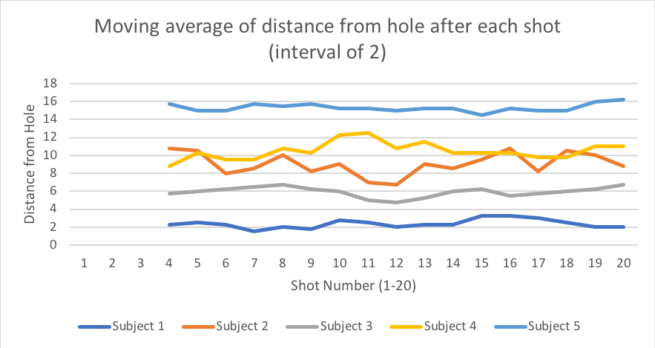

Chart #2 Moving Averages for each shot on interval of 4

